SCHEMA AND DATA DICTIONARY

Table 1 - companies
feature_name | type | description
company_id | INTEGER (UNIQUE) | Unique identifier for each company customer
industry | TEXT | Industry sector of the company (e.g., technology, finance, healthcare, retail)
region | TEXT | Geographic region where the company operates (e.g., NA, EU, APAC)
company_size | INTEGER | Number of employees in the company
annual_revenue | NUMERIC | Estimated annual company revenue in USD
growth_rate | NUMERIC | Annual revenue growth rate of the company
crm_maturity_score | NUMERIC | Score representing how mature the company’s CRM processes are (higher values indicate more structured sales processes)
Expected rows: 30 companies

Table 2 - contracts
feature_name | type | description
contract_id | INTEGER (UNIQUE) | Unique identifier for each contract
company_id | INTEGER (FOREIGN KEY) | Identifier linking the contract to the company
start_date | DATE | Contract start date
end_date | DATE | Contract end date
seats_start | INTEGER | Number of CRM seats/licenses purchased at the start of the contract
seats_end | INTEGER | Number of seats at the end of the contract period (captures expansion or contraction)
contract_value | NUMERIC | Total monetary value of the contract during the contract period
plan_tier | TEXT | Product tier purchased by the company (e.g., Basic, Professional, Enterprise)
discount_pct | NUMERIC | Percentage discount applied to the contract price
sales_channel | TEXT | Sales acquisition channel (e.g., direct sales, partner, self-serve)
Expected rows: 500 contracts

Table 3 - usage_monthly
feature_name | type | description
usage_id | INTEGER | Unique identifier for each usage record
contract_id | INTEGER (FOREIGN KEY) | Identifier linking the usage record to a contract
month | DATE | Month for which the usage metrics were recorded
logins_total | INTEGER | Total number of user login events during the month
active_users | INTEGER | Number of distinct users actively using the platform during the month
leads_created | INTEGER | Number of sales leads created in the CRM during the month
opportunities_created | INTEGER | Number of sales opportunities tracked in the CRM
reports_generated | INTEGER | Number of reports generated from the CRM system
feature_adoption_score | NUMERIC | Composite score measuring adoption of advanced CRM features
Expected rows: 2000 rows

Table 4 - support_tickets_monthly
feature_name | type | description
ticket_month_id | INTEGER | Unique identifier for each monthly support record
contract_id | INTEGER (FOREIGN KEY) | Identifier linking support records to the contract
month | DATE | Month of support activity
ticket_count | INTEGER | Number of support tickets submitted by the customer during the month
avg_resolution_hours | NUMERIC | Average time (in hours) required to resolve support tickets
csat_score | NUMERIC | Customer satisfaction score after support interactions (typically on a 1–5 scale)
escalation_count | INTEGER | Number of tickets escalated to higher-level technical support
Note: CSAT scores may be missing if customers do not submit feedback.

Table 5 - renewals
feature_name | type | description
contract_id | INTEGER (FOREIGN KEY) | Identifier of the contract being evaluated for renewal
renewed | BOOLEAN | Indicator of whether the contract was renewed or churned
renewal_date | DATE | Date when the renewal decision was recorded
seat_change | INTEGER | Change in seat count at renewal

Total Feature Summary
table | Number of features
companies | 7
contracts | 10
usage_monthly | 9
support_tickets_monthly | 7
renewals | 4
Total features across tables: 37

LATENT VARIABLES AND STRUCTURAL MODEL

Latent Variables
variable | distribution | description
product_fit | Normal(0,1) | Measures how well the CRM product fits the company’s workflow and needs
customer_success_quality | Normal(0,1) | Quality of account management and customer support provided to the client
sales_process_maturity | Normal(0,1) | Internal maturity of the company's sales process and CRM adoption
budget_pressure | Normal(0,1) | Financial pressure influencing cost sensitivity and renewal decisions

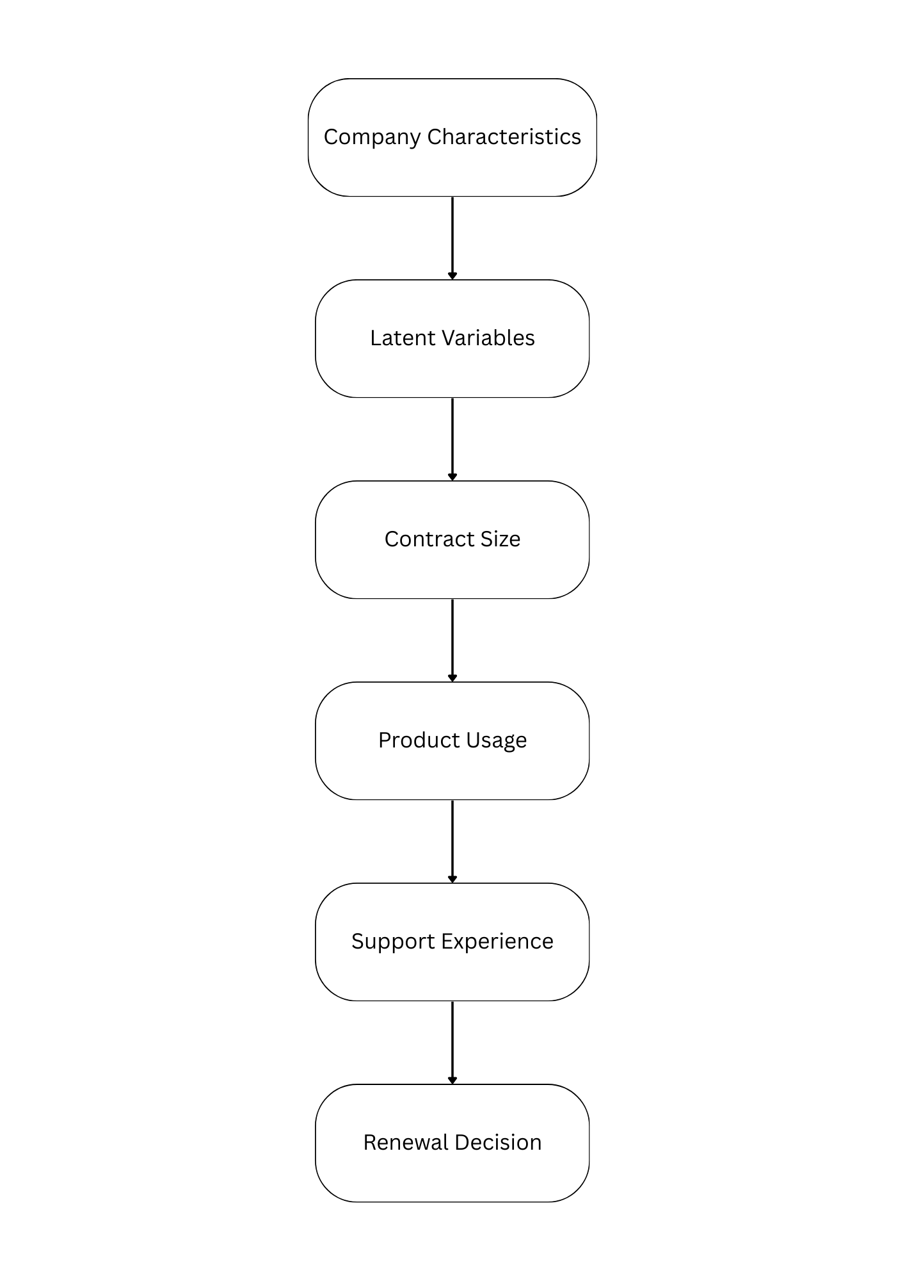
Key Relationships (Conceptual Model)

Structural Equations (Core Model)
- Company Generation
1.1. Company size
$company_size_{i}\sim LogNormal(μ=5,σ=1)$

1.2. Revenue
$annual_revenue_{i}=company_size_{i}×Normal(120000,30000)$

1.3. CRM maturity
$crm_maturity_{i}=σ(0.5×sales_process_maturity_{i}+ϵ)$
where
$ϵ\sim Normal(0,0.5)$
- Contract Generation
2.1. Seats purchased
$seats_start_{i}\sim Poisson(λ=0.12×company_size_{i})$

2.2. Contract value
$contract_value_{i}=seats_start_{i}×price_tier×(1-discount)$

- Monthly Usage Generation
3.1. Active Users
$active_users_{it}$
$=seats_{i}×σ(1.2×product_fit_{i}+0.8×sales_process_maturity_{i}+ϵ)$

3.2. Logins
$logins_{it}=active_users_{it}×Poisson(8)$

3.3. Leads created
$leads_{it}=active_users_{it}×Poisson(2+sales_process_maturity_{i})$

- Support Tickets
4.1. Ticket count
$ticket_count_{it}\sim Poisson(0.03×logins_{it})$

4.2. Resolution time
$resolution_time_{it}=Normal(12-4×customer_success_quality_{i},2)$

4.3. CSAT score
$csat_{it}=3.5+0.6×customer_success_quality_{i}-0.02×ticket_count_{it}+ϵ$

- Renewal Probability (Target Variable)
5.1. Logistic renewal model
$P(renewal_{i})=σ(β_{0}+0.8×usage_{i}+0.6×csat_{i}+0.5×seat_growth_{i}$
$-0.7×tickets_{i}+0.9×produc{t_fit}_{i})$

5.2. Renewal outcome
$renewed_{i}\sim Bernoulli(P(renewal_{i}))$

Sampling Order
- Generate companies
- Generate latent variables
- Generate contracts
- Generate monthly usage
- Generate support tickets
- Compute renewal probability
- Sample renewal outcome
- Remove latent variables
- Export tables

